Leave of Absence request form

Dear Parents / Carers,

Unfortunately, as directed by the government, NO holiday leave will be authorised at Castle Academy.

Exceptional circumstances will be reviewed by the Executive Headteacher and Head of School.

Families with children absent for several days for unauthorised reasons are more likely to receive a fixed penalty notice, whilst families who take students out of school during term time for a family holiday are particularly at risk of this.

If you take your child out of school for an accumulative total of 5 days or more (10 sessions) over a period of ten weeks, the school will deem this as irregular attendance and will consider a referral to the Local authority for consideration of legal action. This could include:

A Penalty Notice payable up to £160 fine.
Prosecution under section 444 (1) Education Act 1996, where if convicted you may be fined up to £1,000.
Prosecution under section 444 (1) (a) Education Act 1996 where if convicted you may be fined up to £2,500 and/or 3 months’ imprisonment.

I must also remind you that the Local Authority impose the fixed penalty notice and the school does not benefit financially from this.

If any child is absent which is unauthorised for longer than 20 school days, they may be taken off the school roll, in which case parents / carers would have to apply for a school place upon return.

Please complete the information on the following page on this form, sign to confirm that you have read this information and return to the school office.

Kind regards,

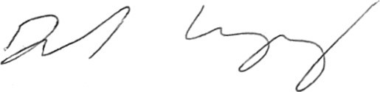

Daniel Lugg
Executive Leader, Castle Academy

Leave of absence request form

Please return to the school office upon completion.

Name of pupil
Class Teacher
First date of absence
Date returning to school
Destination
Reason for absence
Parent details | Mother’s name
Parent details | Mother’s Date of Birth
Parent details | Father’s name
Parent details | Father’s Date of Birth
Address
Signature of Parent/Guardian
Date

---------------------------------------------------------------------------------------------------------------------------------------

Office Use Only - Head of School decision:

I confirm that the above leave request has been authorised

I confirm that the above holiday request has been unauthorised

Head of School Signature………………………………………………………………….

Date …………………………………………………………………………

